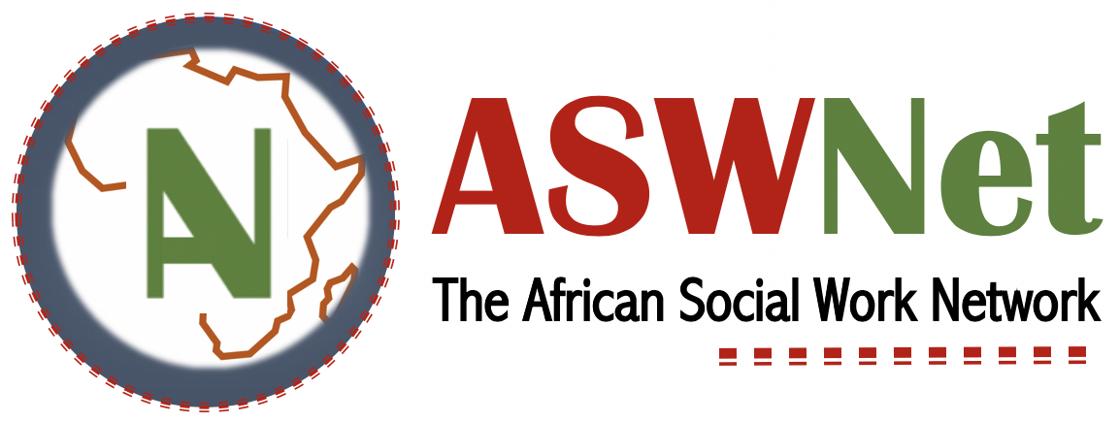
African Social Worker Awards
Nomination Form
1. Details of person nominating
- Name of person nomination
- Email address
2. Details of nominee
- Name of nominee
- Email address
- Social work qualification
3. Why is this person being nominated?
- What work did they do or are they doing?
- Describe where the work was done. It should be clear that the work was done in Africa
- How did the work impact people or how is it impacting people?
4. Evidence
- Provide evidence such as photos, testimonies, short videos, links, statistics or news articles
5. Award you are nominating them for
- Social Worker of the Year
- Lifetime Achievement Award
- Mzee Award
- Decolonising Award
- Developmental Work Award
- Social Work Education Award
- Student Award
- Service Award (for organisations or institutions)

Email your form to: asw@africasocialwork.net before 31 March 2023.

